Experiment 6 V.DEVI PRIYA 192512337
import numpy as np
import pandas as pd
import matplotlib.pyplot as plt

# EXPERIMENT 6(a) AND 6(b)
# IoE Framework and 5G/6G Performance Evaluation

np.random.seed(42)

print("=" * 55)
print("EXPERIMENT 6(a): PEOPLE-PROCESS-DATA-THINGS IoE")
print("=" * 55)

# PART A: PEOPLE-PROCESS-DATA-THINGS FRAMEWORK

n = 20

# Things Layer: Sensor data
temperature = np.random.uniform(20, 40, n).round(2)
humidity = np.random.uniform(30, 90, n).round(2)

# Data Layer: Collect and organize data
data = pd.DataFrame({
"Device_ID": ["Device_" + str(i + 1) for i in range(n)],
"Temperature": temperature,
"Humidity": humidity
})

print("\nTHINGS LAYER: Sensor Data")
print(data.head())

# Process Layer: Edge/Fog processing
data["Edge_Status"] = np.where(
data["Temperature"] > 35, "High Temperature", "Normal"
)

data["Fog_Status"] = np.where(
data["Humidity"] < 40, "Low Humidity", "Normal"
)

print("\nPROCESS LAYER: Edge/Fog Processing")
print(data[["Device_ID", "Edge_Status", "Fog_Status"]].head())

# Simulated MQTT communication
data["MQTT_Topic"] = "ioe/sensors/data"
data["Cloud_Status"] = "Uploaded"

print("\nEDGE/FOG-TO-CLOUD DATA FLOW")
print(data[["Device_ID", "MQTT_Topic", "Cloud_Status"]].head())

# People Layer: Display alerts for users
data["User_Alert"] = np.where(
(data["Edge_Status"] == "High Temperature") |
(data["Fog_Status"] == "Low Humidity"),
"Attention Required", "System Normal"
)

print("\nPEOPLE LAYER: User Alerts")
print(data[["Device_ID", "User_Alert"]].head())

print("\nIoE SUMMARY")
print("Total Devices:", len(data))
print("Cloud Uploaded:", (data["Cloud_Status"] == "Uploaded").sum())
print("Attention Required:", (data["User_Alert"] == "Attention Required").sum())
print("System Normal:", (data["User_Alert"] == "System Normal").sum())

# Save experiment 6(a) results
data.to_csv("experiment6a_results.csv", index=False)

# Graph for 6(a)
plt.figure(figsize=(8, 4))
data[["Temperature", "Humidity"]].plot(marker="o")
plt.title("IoE Sensor Data Monitoring")
plt.xlabel("Device Index")
plt.ylabel("Sensor Value")
plt.tight_layout()
plt.show()

print("\n" + "=" * 55)
print("EXPERIMENT 6(b): 5G AND 6G PERFORMANCE COMPARISON")
print("=" * 55)

# PART B: SIMULATED NETWORK PERFORMANCE
# Illustrative values, not measured real-world results

networks = ["5G", "6G"]

throughput = [1000, 10000] # Mbps
latency = [10, 1] # milliseconds
reliability = [99.9, 99.999] # percentage
energy_efficiency = [80, 95] # illustrative score out of 100

network_data = pd.DataFrame({
"Network": networks,
"Throughput_Mbps": throughput,
"Latency_ms": latency,
"Reliability_Percent": reliability,
"Energy_Efficiency_Score": energy_efficiency
})

print("\nNETWORK PERFORMANCE TABLE")
print(network_data.to_string(index=False))

# Graph 1: Throughput
plt.figure(figsize=(7, 4))
plt.bar(network_data["Network"], network_data["Throughput_Mbps"])
plt.title("5G vs 6G Throughput")
plt.xlabel("Network")
plt.ylabel("Throughput (Mbps)")
plt.tight_layout()
plt.show()

# Graph 2: Latency
plt.figure(figsize=(7, 4))
plt.bar(network_data["Network"], network_data["Latency_ms"])
plt.title("5G vs 6G Latency")
plt.xlabel("Network")
plt.ylabel("Latency (ms)")
plt.tight_layout()
plt.show()

# Graph 3: Reliability
plt.figure(figsize=(7, 4))
plt.bar(network_data["Network"], network_data["Reliability_Percent"])
plt.title("5G vs 6G Reliability")
plt.xlabel("Network")
plt.ylabel("Reliability (%)")
plt.tight_layout()
plt.show()

# Graph 4: Energy efficiency
plt.figure(figsize=(7, 4))
plt.bar(network_data["Network"], network_data["Energy_Efficiency_Score"])
plt.title("5G vs 6G Energy Efficiency")
plt.xlabel("Network")
plt.ylabel("Illustrative Score (out of 100)")
plt.tight_layout()
plt.show()

# Save experiment 6(b) results
network_data.to_csv("experiment6b_results.csv", index=False)

print("\n" + "=" * 55)
print("FINAL RESULT")
print("Experiment 6(a): IoE framework simulation completed.")
print("Experiment 6(b): 5G/6G comparison completed.")
print("Both CSV files saved successfully.")
print("=" * 55)

=======================================================
EXPERIMENT 6(a): PEOPLE-PROCESS-DATA-THINGS IoE
=======================================================

THINGS LAYER: Sensor Data
Device_ID Temperature Humidity
0 Device_1 27.49 66.71
1 Device_2 39.01 38.37
2 Device_3 34.64 47.53
3 Device_4 31.97 51.98
4 Device_5 23.12 57.36

PROCESS LAYER: Edge/Fog Processing
Device_ID Edge_Status Fog_Status
0 Device_1 Normal Normal
1 Device_2 High Temperature Low Humidity
2 Device_3 Normal Normal
3 Device_4 Normal Normal
4 Device_5 Normal Normal

EDGE/FOG-TO-CLOUD DATA FLOW
Device_ID MQTT_Topic Cloud_Status
0 Device_1 ioe/sensors/data Uploaded
1 Device_2 ioe/sensors/data Uploaded
2 Device_3 ioe/sensors/data Uploaded
3 Device_4 ioe/sensors/data Uploaded
4 Device_5 ioe/sensors/data Uploaded

PEOPLE LAYER: User Alerts
Device_ID User_Alert
0 Device_1 System Normal
1 Device_2 Attention Required
2 Device_3 System Normal
3 Device_4 System Normal
4 Device_5 System Normal

IoE SUMMARY
Total Devices: 20
Cloud Uploaded: 20
Attention Required: 6
System Normal: 14
<Figure size 800x400 with 0 Axes>
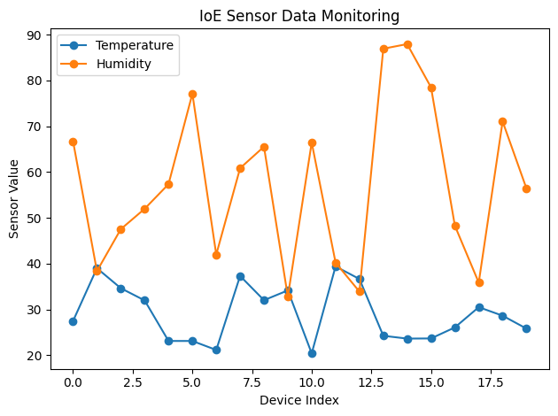
=======================================================
EXPERIMENT 6(b): 5G AND 6G PERFORMANCE COMPARISON
=======================================================

NETWORK PERFORMANCE TABLE
Network Throughput_Mbps Latency_ms Reliability_Percent Energy_Efficiency_Score
5G 1000 10 99.900 80
6G 10000 1 99.999 95
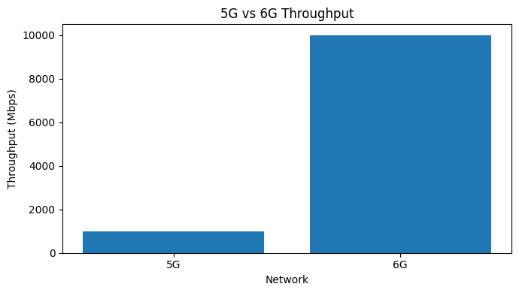
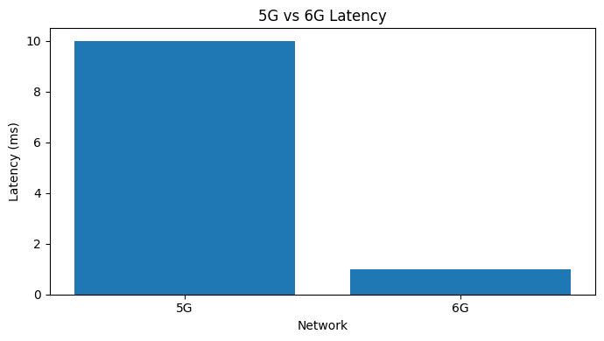
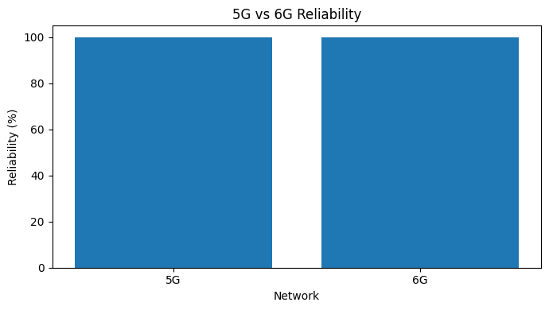
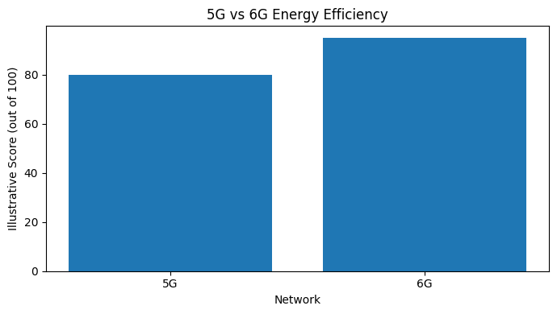
=======================================================
FINAL RESULT
Experiment 6(a): IoE framework simulation completed.
Experiment 6(b): 5G/6G comparison completed.
Both CSV files saved successfully.
=======================================================

